1. Write the SQL Queries for the following queries (use emp_table and dept_table of Experiment 4).

Ques1: List the Deptno where there are no emps.

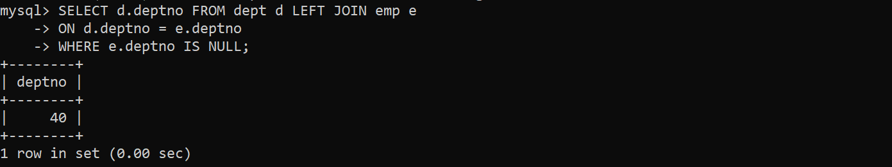

Ques2: List the No.of emp’s and Avg salary within each department for each job.

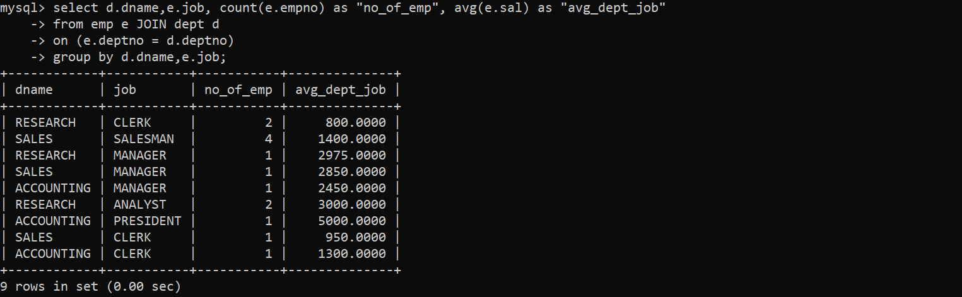

Ques3: Find the maximum average salary drawn for each job except for ‘President’.

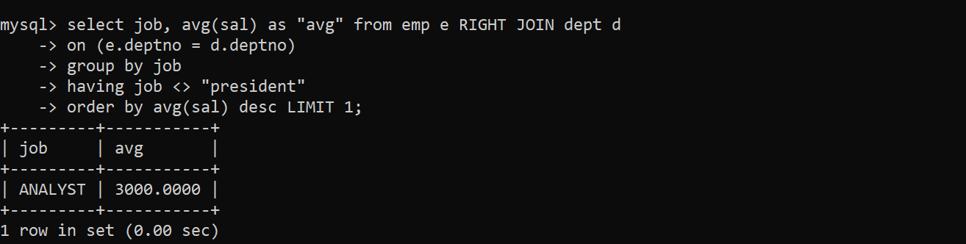

Ques4: List the department details where at least two emps are working.

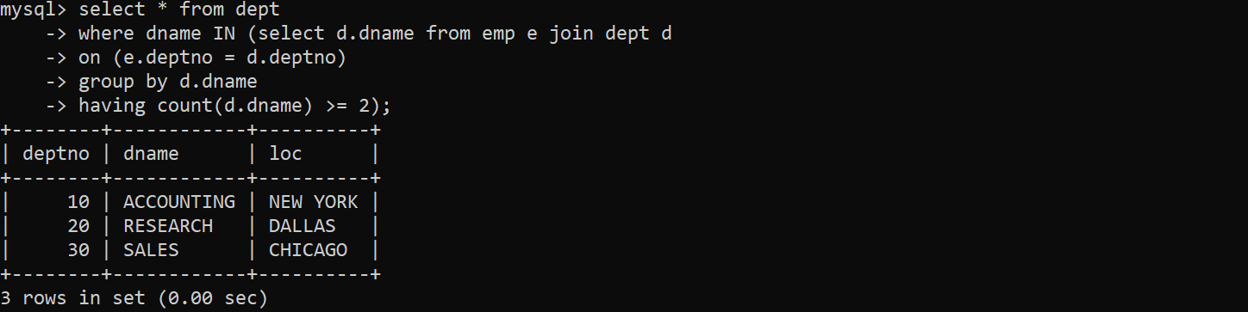

Ques5: List the no. of emps in each department where the no. is more than 3.

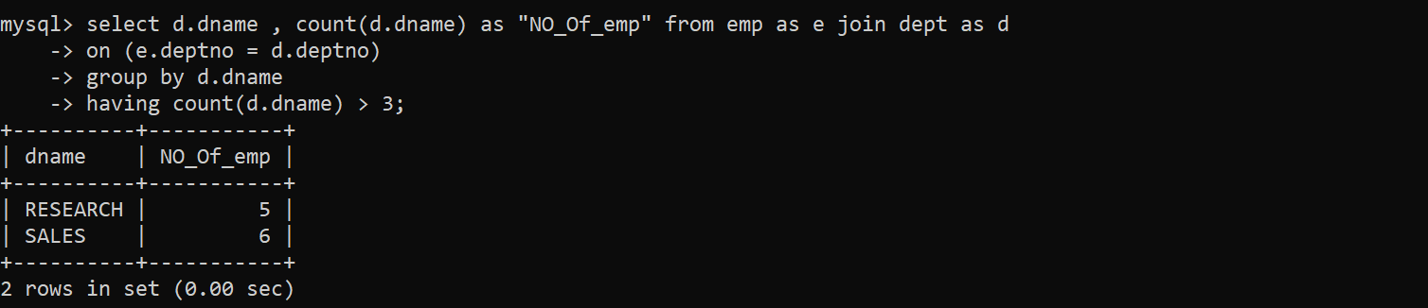

Ques6: List the names of the emps who are getting the highest sal dept wise.

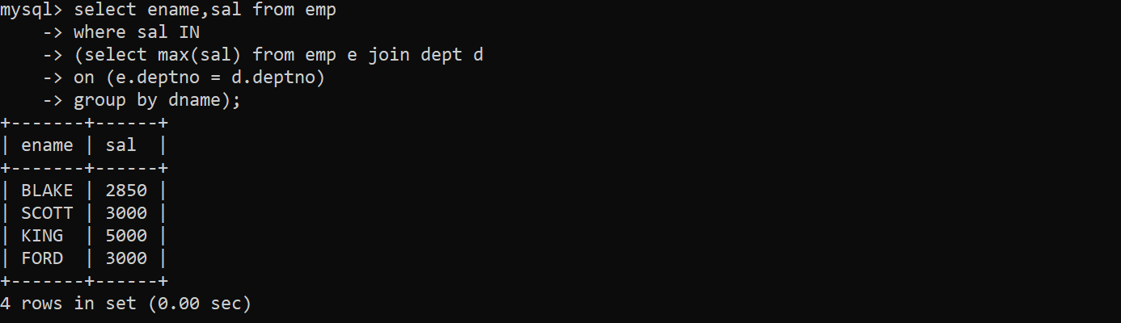

Ques7: List the Deptno and their average salaries for dept with the average salary less than the averages for all departments.

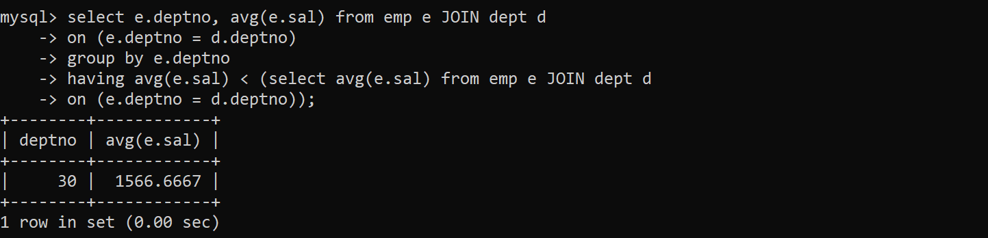

2. Execute the experiment 4 using sql join.

Ques1: List the details of the emps whose Salaries more than the employee BLAKE.

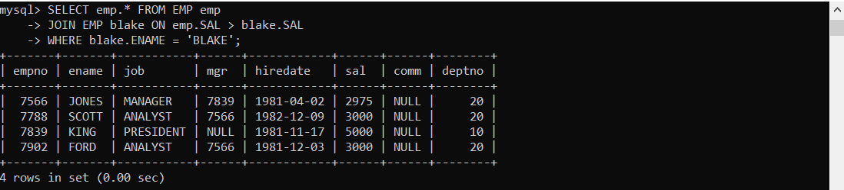

Ques2: List the emps whose Jobs are same as ALLEN.

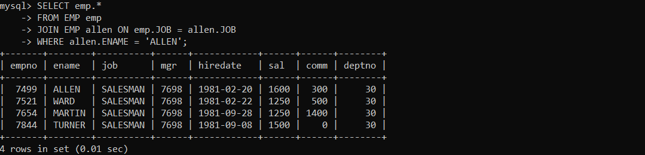

Ques3: List the Emps whose Sal is same as FORD or SMITH in desc order of Name

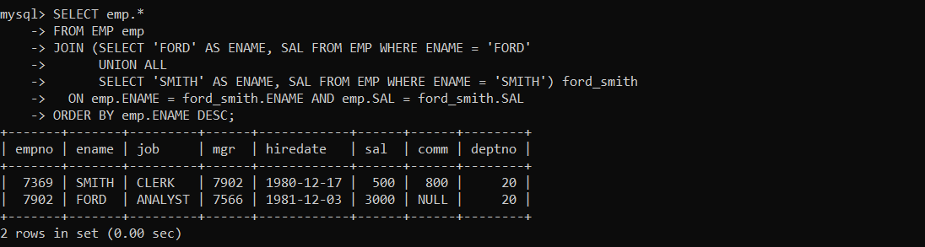

Ques4: List the emps Whose Jobs are same as MILLER or Sal is more than ALLEN. 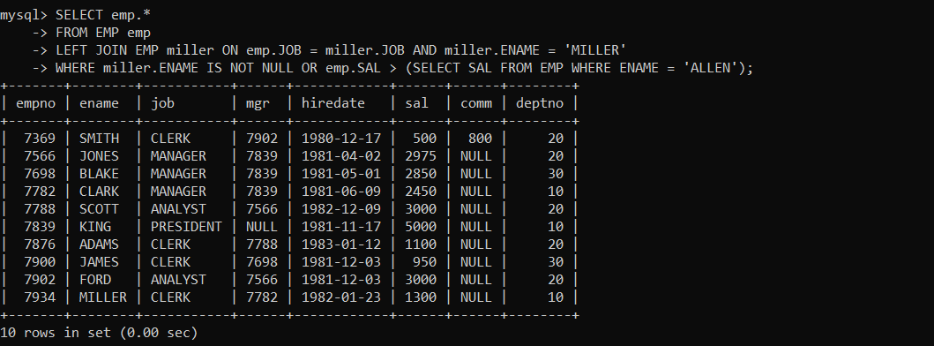

Ques5 Find the highest paid employee of sales department.

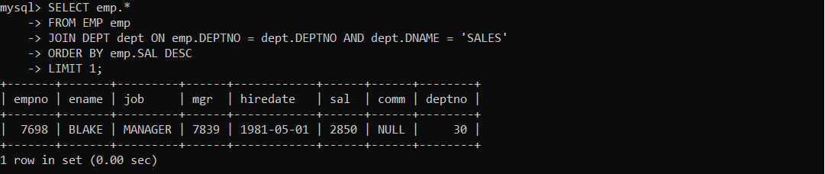

Ques6 List the employees who are senior to most recently hired employee working under king.

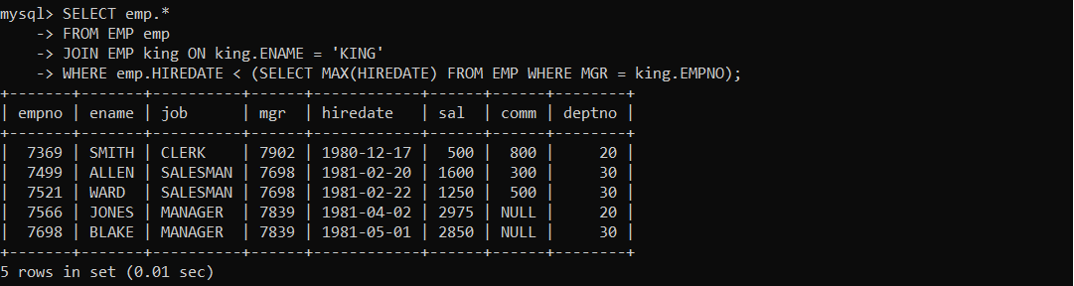

Ques7 List the names of the emps who are getting the highest sal dept wise.

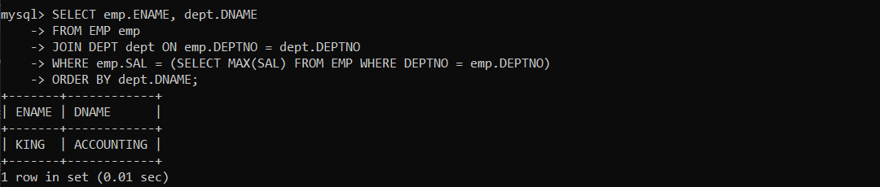

Ques8 List the emps whose sal is equal to the average of max and minimum

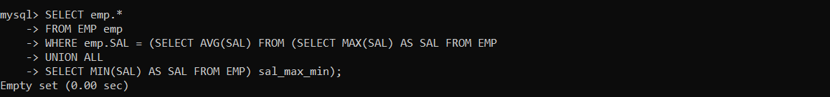

Ques9 List the emps who joined in the company on the same date.

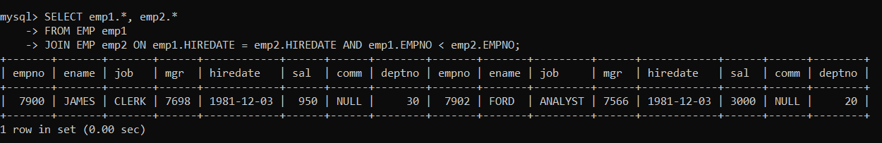

Ques10 Find out the emps who joined in the company before their Managers.

